Signal Generator and Oscilloscope Lab Graphs

Experiment 1 Graphs
Input Voltage Signal
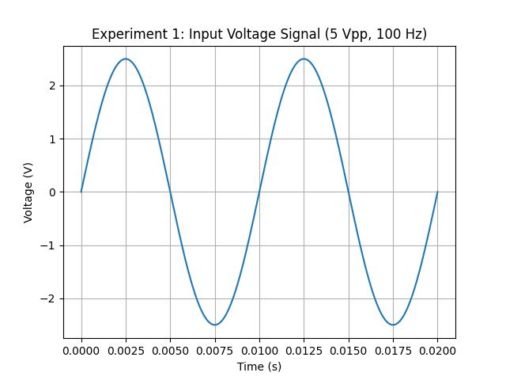
Voltage across R1
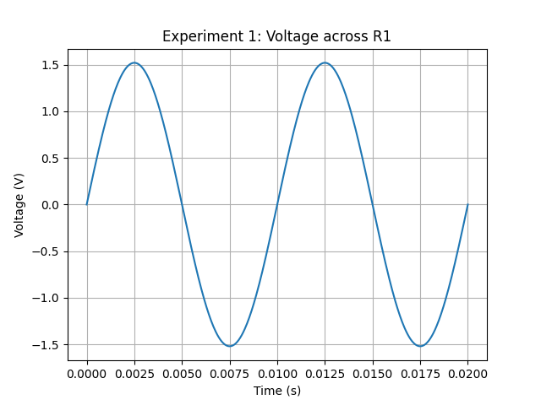
Voltage across R2
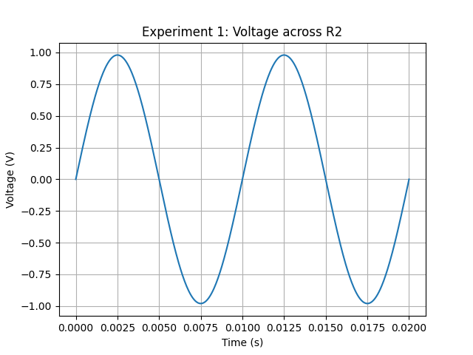

Experiment 2 Graphs
Input Voltage Signal
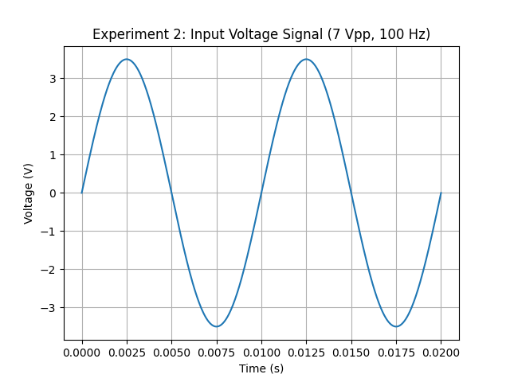
Voltage across R1
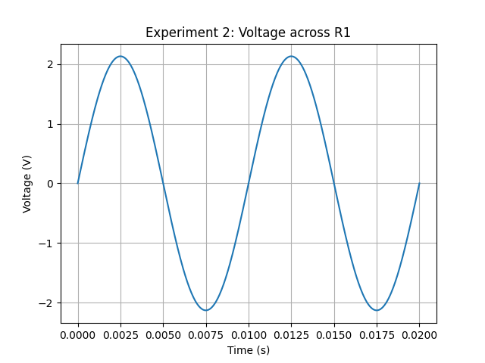
Voltage across R2
